SOFTWARE REQUIREMENTS SPECIFICATION
CUT Clinic Appointment Management System
Work Integrated Learning in Information Technology
2026_ITC327W_2_4
Group: All Safe Tech
Stakeholder: CUT Clinic
Project Type: Academic Prototype
Final Version

Document Control
Item | Details
Project Title | CUT Clinic Appointment Management System
Document | Software Requirements Specification
Module | Work Integrated Learning in Information Technology
Module Code | 2026_ITC327W_2_4
Stakeholder | CUT Clinic
Primary Users | CUT Students and Authorised Clinic Staff
Mobile Technology | Flutter / Dart
Web Technology | ASP.NET Core / C#
Backend | Supabase / PostgreSQL
Version Control | GitHub
Version | 3.0 – Phase 2 / System Architecture and Design
Document Status | Updated SRS – Phase 1 + Phase 2 design; editable diagram/source placeholders included

1. Group Members
No. | Group Member | Student Number | Responsibility
1 | S Vatsha | 222044842 | Group Leader, System Analysis & Documentation
2 | EVP Mandlazi | 222036964 | QA Tester & Notification API Specialist
3 | AN Sipeto | 221019978 | UI/UX Designer & Mobile Interface Testing
4 | TG Lukhwareni | 223006810 | ASP.NET Core Web Developer
5 | M Masinga | 223040081 | Backend & Supabase Database
6 | N Dastile | 221005680 | Technical Writer & Project Schedule Controller
7 | V Langa | 222016838 | Flutter Mobile Developer & Integration

.

2. Stakeholder and Organisation
The stakeholder organisation is the CUT Clinic. The primary stakeholder identified for consultation is the CUT Clinic Supervisor. The clinic is the environment in which the current student appointment process takes place. The proposed project focuses specifically on improving the appointment-request and appointment-communication process rather than replacing the clinic's complete operational or healthcare system.
Stakeholder / User | Role in Proposed System
CUT Clinic Supervisor | Primary stakeholder providing requirements, feedback and validation.
CUT Students | Mobile application users who register, request and manage appointments.
Authorised Clinic Staff | Web application users who manage appointment requests and schedules.
SMS Service | External service used for SMS notifications.
Email Service | External service used for email notifications.

3. Unit 1 Findings
Unit 1 established the stakeholder problem, current process, proposed solution, initial requirements, project scope and technology direction. The stakeholder-confirmed findings carried forward into the refined SRS are summarised below.
Finding | Unit 1 Result
Current appointment request method | Students request appointments through Outlook/email or telephone.
Communication problem | Only two staff members receive the relevant email communication, creating a dependency on their availability.
Main affected users | Students, because responses may be delayed and students may not regularly check Outlook.
Appointment scheduling | Clinic staff determine and assign the appointment date and time.
Cancellation | Students may cancel appointments.
Rescheduling | Students do not reschedule themselves; authorised clinic staff can reschedule.
Appointment limit | A student may have only one active appointment at a time.
Notifications | Students should receive SMS and email notifications.
Reminder | Students should receive a day-before appointment reminder.
Student registration | Registration is restricted to CUT students and requires a valid CUT student number or proof of registration.
Technology direction | Flutter mobile application, ASP.NET Core web application and Supabase/PostgreSQL backend.

4. Problem Statement
The CUT Clinic currently relies mainly on Outlook/email and telephone communication for student appointment requests and related communication. Only two people currently receive the relevant email communication. If both staff members are unavailable, appointment requests and responses may be delayed. Students are the primary affected users because they may not receive responses in time and may not regularly check Outlook. This creates uncertainty about appointment status and makes appointment communication less efficient. The current process also does not provide students with a centralised platform where they can view their appointment status and assigned appointment information. An improved solution is therefore needed to centralise appointment information, reduce dependence on individual Outlook inboxes and provide students with timely communication through SMS and email notifications, including a day-before appointment reminder.

5. Project Aim and Objectives

5.1 Project Aim
The aim of the project is to develop an integrated prototype that improves the management and communication of CUT Clinic student appointments through a centralised digital process.

5.2 Project Objectives
- Provide student registration and secure login through a mobile application.
- Restrict appointment functionality to CUT students.
- Allow students to submit appointment requests.
- Provide clinic staff with a web application for managing appointment requests.
- Centralise appointment information using Supabase.
- Allow authorised clinic staff to assign appointment dates and times.
- Allow students to view their appointment status and assigned date/time.
- Allow students to cancel appointments.
- Allow authorised clinic staff to process cancellations and reschedule appointments.
- Prevent students from having more than one active appointment at a time.
- Provide SMS and email notifications for important appointment events.
- Provide a day-before appointment reminder.
- Reduce dependence on individual Outlook inboxes.

6. Project Scope

6.1 In-Scope Functions
- CUT student registration.
- Student login and authentication.
- Authorised clinic staff login.
- Appointment requests.
- Appointment request management.
- Appointment approval and rejection.
- Appointment date/time assignment by clinic staff.
- Appointment status viewing.
- Student cancellation.
- Clinic staff cancellation processing.
- Clinic staff rescheduling.
- One active appointment per student.
- SMS notifications.
- Email notifications.
- Day-before appointment reminders.
- Centralised appointment storage.
- Access control.
- Appointment history where applicable.

6.2 Deliverables
- Initial/refined SRS.
- Flutter mobile prototype.
- ASP.NET Core web prototype.
- Supabase backend/database.
- UML documentation.
- ERD/database documentation.
- GitHub repository.
- Microsoft Project schedule.
- Testing and evaluation documentation.
- Final project demonstration.

6.3 Acceptance Criteria
- A CUT student can register.
- Registration requires a valid CUT student number or proof of registration.
- A registered student can log in.
- An authorised clinic staff member can log in.
- A student can submit an appointment request.
- The appointment request is stored in Supabase.
- Clinic staff can view appointment requests.
- Clinic staff can approve or reject requests.
- Clinic staff can assign an appointment date and time.
- A student can view appointment status.
- A student can view the assigned appointment date and time.
- A student can cancel an appointment.
- Clinic staff can process cancellations.
- Clinic staff can reschedule appointments.
- The system prevents conflicting active appointments.
- SMS/email notification functionality can be demonstrated.
- A day-before reminder can be demonstrated.
- Unauthorised users cannot access protected functions.
- Appointment information is shared correctly between the mobile application, web application and backend.

6.4 Refined Project Boundaries
The prototype is limited to appointment management and communication. It does not replace the complete clinic system.
- Separate System Administrator role is excluded.
- Direct integration with CUT student-information systems is excluded from the prototype.
- Medical records, diagnoses, prescriptions and clinical treatment management are excluded.
- Online consultations are excluded.
- Payments and billing are excluded.
- Production deployment is excluded unless separately authorised.
- Guaranteed production SMS/email delivery is not claimed.

6.5 Constraints
- Limited academic timeframe.
- Seven-member project group.
- Prototype rather than production healthcare system.
- Dependence on internet connectivity.
- Dependence on Supabase availability.
- Dependence on external SMS/email services.
- Limited access to confidential CUT systems.
- Limited access to real student information.
- Limited development and testing time.

6.6 Assumptions
- The CUT Clinic stakeholder will provide feedback when required.
- Students have suitable smartphones and internet access.
- Clinic staff have access to a computer and internet connection.
- Supabase remains available during development.
- Test data will be used during development.
- External notification services may be available for demonstration.
- Production requirements may differ from the academic prototype.
- Further institutional approval would be required before production deployment.

7. Stakeholders and Users
The prototype has two primary human user groups: CUT Students and Authorised Clinic Staff. There is no separate System Administrator role in the current project scope.
User / Stakeholder | Role
CUT Clinic Supervisor | Stakeholder providing requirements, feedback and validation.
CUT Students | Register, log in, request appointments, view status/date/time and cancel appointments.
Authorised Clinic Staff | View requests, approve/reject, assign dates/times, process cancellations and reschedule appointments.

8. Current Process
Students currently contact the clinic through Outlook/email or telephone. Clinic staff receive and review the request, determine the appointment date/time, and communicate the appointment information to the student. The current process has a dependency on two staff members receiving the relevant email communication.

8.1 Current Process Steps
- Student contacts the clinic through Outlook/email or telephone.
- Clinic staff receive and review the request.
- Clinic staff communicate appointment information.
- Clinic staff determine the appointment date and time.
- Student may contact the clinic again when cancellation is required.

8.2 Current Process Problems
- Only two staff members receive the relevant email communication.
- If both staff members are unavailable, responses may be delayed.
- Students may not regularly check Outlook.
- Students may not receive appointment information in time.
- Students may be uncertain about appointment status.
- Appointment information is not centralised.
- The process depends heavily on email and telephone communication.

8.3 Current Process Diagram
Student → Outlook/Email or Telephone → Clinic Staff Receive Request → Staff Review Request → Staff Determine Appointment Date/Time → Appointment Information Communicated to Student
Key issue: only two staff members receive the relevant appointment emails.

9. Proposed System / Product Perspective
The proposed system combines a Flutter student mobile application, an ASP.NET Core clinic web application, a Supabase backend, a PostgreSQL database and SMS/email notification services.
High-level flow: Student → Flutter Mobile Application → Supabase Backend/Database → ASP.NET Core Web Application → Authorised Clinic Staff. Appointment events may also trigger SMS and email notifications to the student.
Component | Main Functions
Flutter Mobile Application | Registration, login, appointment request, status/date/time viewing, cancellation and notifications.
ASP.NET Core Web Application | Staff login, request management, approval/rejection, scheduling, cancellation and rescheduling.
Supabase | Authentication and centralised student/staff/appointment data.
Notification Services | SMS/email approval, rejection, cancellation, rescheduling and reminders.

10. Functional Requirements

10.1 Student and Authentication Requirements
ID | Requirement | Priority
FR1 | The student shall be able to create an account. | Must Have
FR2 | The student shall provide a valid CUT student number or proof of registration. | Must Have
FR3 | Appointment functionality shall be restricted to registered CUT students. | Must Have
FR4 | The student shall be able to log in securely. | Must Have
FR5 | Authorised clinic staff shall be able to log in. | Must Have
FR6 | Clinic functions shall be restricted to authorised clinic staff. | Must Have
FR7 | Users shall be able to log out. | Must Have

10.2 Appointment Requirements
ID | Requirement | Priority
FR8 | The student shall be able to submit an appointment request. | Must Have
FR9 | The system shall record the appointment request date/time. | Must Have
FR10 | Clinic staff shall be able to view appointment requests. | Must Have
FR11 | Clinic staff shall be able to approve or reject appointment requests. | Must Have
FR12 | Clinic staff shall be able to assign an appointment date and time. | Must Have
FR13 | The system shall prevent conflicting exclusive appointment slots. | Must Have
FR14 | The student shall not be able to create more than one conflicting active appointment. | Must Have
FR15 | The student shall be able to view appointment status. | Must Have
FR16 | The student shall be able to view the assigned appointment date and time. | Must Have
FR17 | The student shall be able to cancel an appointment. | Must Have
FR18 | Authorised clinic staff shall be able to process cancellations and reschedule appointments. | Must Have
FR19 | Appointment changes should be recorded. | Should Have

10.3 Notification Requirements
ID | Requirement | Priority
FR20 | The system shall send an SMS/email notification when an appointment is approved. | Must Have
FR21 | The system shall send an SMS/email notification when an appointment is rejected. | Must Have
FR22 | The system shall send an SMS/email notification when an appointment is cancelled. | Must Have
FR23 | The system shall send an SMS/email notification when an appointment is rescheduled. | Must Have
FR24 | The system shall provide a day-before appointment reminder. | Must Have
FR25 | Notification events should be recorded where supported. | Should Have

10.4 Appointment Data Requirements
ID | Requirement | Priority
FR26 | The appointment date and time shall be stored. | Must Have
FR27 | The appointment status shall be stored. | Must Have
FR28 | Each appointment shall be associated with the relevant student. | Must Have
FR29 | Clinic staff shall be able to view upcoming appointments. | Must Have
FR30 | Student appointment history should be available where applicable. | Should Have

11. Non-Functional Requirements

11.1 Security and Privacy
ID | Requirement
NFR1 | Authentication shall be required for protected functions.
NFR2 | Students shall access only their own appointments.
NFR3 | Staff access shall be restricted to authorised accounts.
NFR4 | Passwords shall not be stored as plain text.
NFR5 | Secrets and API keys shall not be stored in GitHub.
NFR6 | Secure communication shall be used.
NFR7 | Test data shall be used during development.
NFR8 | Only necessary student data shall be collected.
NFR9 | Appointment information shall be protected.
NFR10 | Unnecessary medical records shall not be stored.
NFR11 | Real student information shall only be used with appropriate authorisation.

11.2 Usability
ID | Requirement
NFR12 | The mobile interface shall be simple and understandable.
NFR13 | The clinic web interface shall be clear and easy to use.
NFR14 | Error messages shall be understandable.
NFR15 | Students shall be able to determine appointment status without relying on Outlook.
NFR16 | The mobile interface shall support common smartphone screen sizes.
NFR17 | Unnecessary appointment request steps shall be minimised.

11.3 Performance and Reliability
ID | Requirement
NFR18 | Normal user actions shall respond within a reasonable time.
NFR19 | Appointment updates shall occur without unnecessary delay.
NFR20 | The prototype shall support multiple test users.
NFR21 | Appointment data shall remain consistent.
NFR22 | Failed operations shall display appropriate errors.
NFR23 | Incomplete appointment records shall be prevented where possible.
NFR24 | Duplicate/conflicting appointment assignments shall be prevented.
NFR25 | The system shall be available when internet and backend services are available.
NFR26 | Temporary network failures shall be handled gracefully.

11.4 Maintainability
ID | Requirement
NFR27 | Code shall be organised into appropriate modules.
NFR28 | GitHub shall be used for version control.
NFR29 | Clear naming and documentation shall be maintained.
NFR30 | Secrets shall be separated from source code.

11.5 Compatibility and Notifications
ID | Requirement
NFR31 | The prototype shall support Android testing.
NFR32 | The clinic web application shall support modern browsers.
NFR33 | The system shall operate under normal internet conditions.
NFR34 | Notifications shall clearly identify the relevant appointment.
NFR35 | Notifications shall be sent only to relevant contact details.
NFR36 | Notification processing shall be recorded where supported.
NFR37 | The system shall identify confirmed appointments requiring day-before reminders.

12. Integration Requirements
ID | Requirement
IR1 | Flutter shall communicate with the backend for registration and authentication.
IR2 | Appointment requests submitted through Flutter shall be stored in Supabase.
IR3 | Flutter shall retrieve appointment information from the backend.
IR4 | Flutter shall display appointment status.
IR5 | ASP.NET Core shall authenticate authorised clinic staff.
IR6 | The web application shall retrieve appointment requests.
IR7 | Clinic staff shall update appointment status through the web application.
IR8 | Assigned appointment date/time shall be stored in Supabase.
IR9 | Staff appointment changes shall be reflected in the student application.
IR10 | Appointment requests shall be stored in Supabase.
IR11 | Appointment status, date and time shall be stored in Supabase.
IR12 | Student accounts shall be associated with appointments.
IR13 | Database access controls shall be applied.
IR14 | Authentication shall distinguish between student and staff access.
IR15 | Students shall not access staff functions.
IR16 | Staff functions shall be restricted to authorised clinic staff.
IR17 | Approval notifications shall be triggered after approval.
IR18 | Rejection notifications shall be triggered after rejection.
IR19 | Cancellation notifications shall be triggered after cancellation.
IR20 | Rescheduling notifications shall be triggered after rescheduling.
IR21 | The system shall identify appointments occurring the following day.
IR22 | SMS/email reminders shall be initiated where the notification service supports them.
IR23 | Duplicate reminders shall be prevented where supported.
IR24 | Student requests shall become available to authorised clinic staff.
IR25 | Staff updates shall be reflected in the student application.
IR26 | Each appointment shall have a unique identifier.
IR27 | Conflicting appointment assignments shall be prevented.
IR28 | Notification failure shall not automatically cancel an appointment.
IR29 | Failed notifications shall be recorded where supported.
IR30 | Integration failures shall display an appropriate status or error.

13. System / Technology Requirements
ID | Requirement
SR1 | Flutter shall be used for the mobile application.
SR2 | ASP.NET Core shall be used for the web application.
SR3 | Supabase shall be used as the shared backend.
SR4 | PostgreSQL shall be used as the database.
SR5 | GitHub shall be used for version control.
SR6 | SMS/email services shall be used where available.
SR7 | Secure authentication shall be implemented.
SR8 | Android smartphone support shall be provided for prototype testing.
SR9 | Internet connectivity shall be required for backend operations.
SR10 | The mobile application shall communicate with the backend.
SR11 | The mobile application shall provide registration, login and appointment functions.
SR12 | The web application shall be developed using ASP.NET Core.
SR13 | The web application shall be accessible through a modern browser.
SR14 | Secure clinic staff authentication shall be provided.
SR15 | The web application shall communicate with the backend.
SR16 | The web application shall provide appointment management functions.
SR17 | A Supabase project shall be used.
SR18 | PostgreSQL shall be used for structured data.
SR19 | Supabase shall store required appointment and user data.
SR20 | Supabase Authentication shall be used where appropriate.
SR21 | Database access shall be restricted.
SR22 | Private Supabase credentials shall be kept secure.

14. Technical Feasibility
Technology | Finding
Flutter | Suitable for the student mobile application.
Dart | Suitable for Flutter development.
ASP.NET Core | Suitable for the clinic staff web application.
C# | Suitable for ASP.NET Core development.
Supabase | Suitable for backend and database services.
PostgreSQL | Suitable for structured appointment data.
GitHub | Suitable for version control and group collaboration.

Decision: KEEP. The technology stack will remain unchanged. SMS and email functionality will be treated as an external dependency. If production notification services are unavailable, test or simulated notification functionality will be used for the prototype demonstration.

15. Operational Feasibility
The proposed system is operationally feasible because it supports the existing clinic appointment process while reducing communication problems. The current process depends on Outlook/email and telephone communication, and only two staff members currently receive the relevant email communication. The proposed system provides centralised appointment requests, a central clinic staff interface, student appointment status visibility, appointment notifications and reminders.
Decision: KEEP. The proposed workflow will remain part of the project.

16. Economic Feasibility
Resource | Purpose
Flutter | Mobile application development
ASP.NET Core | Web development
Supabase | Backend/database
PostgreSQL | Database
GitHub | Version control
Visual Studio / development environment | Application development

Production hosting, commercial SMS services and other production costs are outside the prototype budget. Decision: KEEP. The project remains financially feasible as an academic prototype.

17. Schedule Feasibility
- Limited development time.
- Stakeholder availability.
- Mobile/web/backend integration.
- Notification service integration.
- Testing.
- Documentation.
Decision: SIMPLIFY WHERE NECESSARY. The group will prioritise the Minimum Viable Product. Advanced functions will be postponed rather than allowing them to delay the core system.

18. Legal Feasibility
- Use test data during development.
- Avoid storing unnecessary medical information.
- Avoid direct integration with CUT production systems.
- Protect authentication credentials.
- Keep confidential information out of GitHub.
- Require appropriate authorisation before real student data is used.
Decision: KEEP WITH PRIVACY CONTROLS. The academic prototype will remain within the agreed boundaries.

19. Ethical Feasibility
- Collect only necessary information.
- Protect student appointment information.
- Prevent students from accessing other students' appointments.
- Restrict clinic functions to authorised staff.
- Avoid unnecessary medical records.
- Use test data during development.
Decision: KEEP. Ethical and privacy principles will be incorporated into the system design.

20. Feasibility Conclusion
Area | Decision | Reason
Technical | Keep | Proposed technology stack is suitable.
Operational | Keep | Improves the current appointment process.
Economic | Keep | Prototype can use available academic technologies.
Schedule | Simplify | Core MVP must be prioritised.
Legal | Keep | Test data and privacy controls reduce risk.
Ethical | Keep | Student information will be protected.

Overall Feasibility Decision: The CUT Clinic Appointment Management System is considered feasible as an academic prototype. The project will continue with the refined scope described in this SRS.

21. Project Risks
ID | Risk | Likelihood | Impact | Level | Mitigation
R01 | Stakeholder taking time to send the confirmation letter as proof | high | High | High | Approach the stakeholder physically and get the letter.
R02 | SMS/email service unavailable | Medium | High | High | Use test or simulated notification services.
R03 | Supabase integration problems | Medium | High | High | Test backend integration early.
R04 | Project exceeds academic timeframe | High | High | High | Prioritise MVP and monitor Microsoft Project schedule.
R05 | GitHub accidentally contains secrets | Low | High | High | Use .gitignore and environment variables.
R06 | Student information is exposed | Low | High | High | Use test data and access controls.
R07 | Flutter and ASP.NET integration problems | Medium | Medium | Medium | Test components independently before integration.
R08 | Stakeholder requirements change | Medium | Medium | Medium | Update SRS and change log when requirements change.
R09 | Limited access to CUT systems/data | High | Medium | High | Use test data and exclude direct institutional integration.
R10 | Internet connectivity problems | Medium | Medium | Medium | Provide appropriate error handling and controlled test scenarios.

21.1 Three Highest Priority Risks
- R01 – Stakeholder is taking time : get contact with the stakeholder as soon as possible and get the confirmation letter.
- R02 – SMS/email notification dependency: use test or simulated notification services where necessary.
- R03 – Student information security: use test data, authentication, role restrictions and secure storage.
21.2 SWOT analysis
Strengths | Weaknesses
1. Centralises appointment management. | 1. Requires internet connectivity.
2. Reduces dependence on the two staff members receiving emails. | 2. Depends on external SMS/email services.
3. Provides students with SMS and email notifications. | 3. Limited development time as a school project.
4. Provides day-before appointment reminders. | 4. Limited access to existing CUT systems.
5. Allows clinic staff to manage appointments more efficiently. | 5. Prototype may not include all production-level features.

22. Requirements Change Log
Requirement ID | Original Requirement | Change Made | Reason for Change
FR2 | Student must provide a CUT student number. | Student must provide a valid CUT student number or proof of registration. | Reflects the agreed registration approach.
FR18 | Clinic admin can process cancellations or reschedule appointment. | Authorised clinic staff can process cancellations and reschedule appointments. | No separate System Administrator role is included.
FR20–FR24 | SMS/email notifications. | Notification functionality retained with possible test/simulated services. | External notification services may not be available for production.
SR6 | SMS/Email service available. | SMS/email service treated as an external dependency. | Reduces technical and schedule risk.
IR22 | SMS/email reminder initiated. | Reminder retained as a prototype functionality. | Important stakeholder requirement but production delivery cannot be guaranteed.
Scope | Direct CUT-system integration. | Postponed. | Requires institutional access and authorisation.
Scope | Online payment. | Removed. | Not required for the appointment-management problem.
Scope | Medical records. | Removed. | Outside the project scope and introduces additional privacy risk.

23. Refined Scope
Function | Decision | Reason
Student registration | Keep | Essential for system access.
Student login | Keep | Required for security.
Clinic staff login | Keep | Required to protect clinic functions.
Appointment request | Keep | Core stakeholder requirement.
Appointment approval/rejection | Keep | Required for clinic staff management.
Staff assigns appointment date/time | Keep | Reflects current clinic process.
Student views appointment status | Keep | Reduces uncertainty and communication delays.
Student views appointment date/time | Keep | Important for appointment communication.
Student cancellation | Keep | Stakeholder confirmed requirement.
Staff rescheduling | Keep | Students do not reschedule themselves.
One active appointment per student | Keep | Stakeholder confirmed requirement.
SMS notifications | Keep, with prototype limitation | Important requirement but dependent on external service.
Email notifications | Keep, with prototype limitation | Important requirement but dependent on external service.
Day-before reminder | Keep, with prototype limitation | Stakeholder confirmed requirement.
Online payments | Remove | Not required for solving the appointment problem.
Medical records | Remove | Outside the appointment-management scope.
Online consultation | Remove | Outside current project scope.
Direct CUT system integration | Postpone | Requires institutional access and approval.
Push notifications | Postpone | Future enhancement.
Analytics dashboard | Postpone | Not essential to MVP.
Calendar integration | Postpone | Future enhancement.
Advanced reporting | Postpone | Not essential to MVP.

24. Stakeholder Confirmation
Item | Details
Stakeholder | CUT Clinic Supervisor
Date | 26 Aug 2026
Changes Discussed | Refined project scope, notification implementation, registration requirements, cancellation/rescheduling and prototype limitations.
Reason | Feasibility, risk, academic timeframe and technical limitations.
Stakeholder Comments | Like the idea and will provide all necessary information
Changes Accepted | Yes / No / Changes Requested
Evidence | Meeting notes / email / signed confirmation

Stakeholder comments:
We like the idea and we provide wall necessary information . Sorry we can’t provide the confirmation Letter in time
Stakeholder Name: Ms Mpuru Mathabo (Superviosor)
Signature: M.M
Date: 26 Aug 2026

26. Updated Microsoft Project Schedule

27. GitHub and Supabase Project Evidence

27.1 GitHub
The project GitHub repository is CUT-Clinic-Appointment-Management-System. The repository is private and should contain organised project documentation and source code. Passwords, API keys, private Supabase keys, stakeholder contact details, confidential student information and real patient/medical information must not be committed.
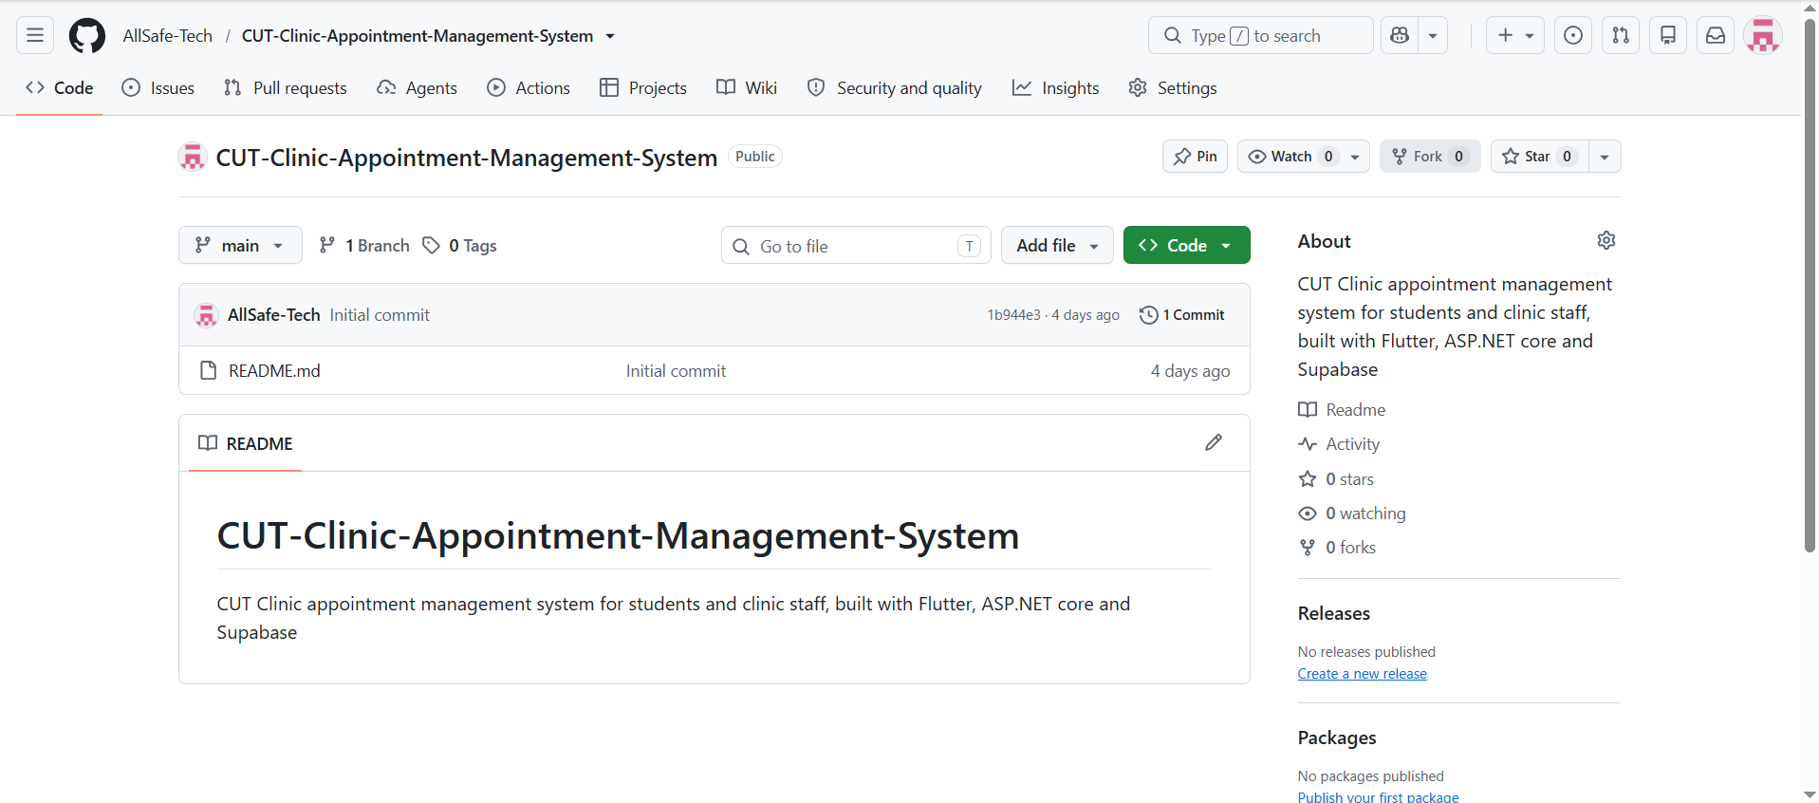

27.2 Supabase
Supabase will be used as the shared backend and will provide PostgreSQL, authentication, database storage, appointment information, student information required by the prototype and staff information required by the prototype.
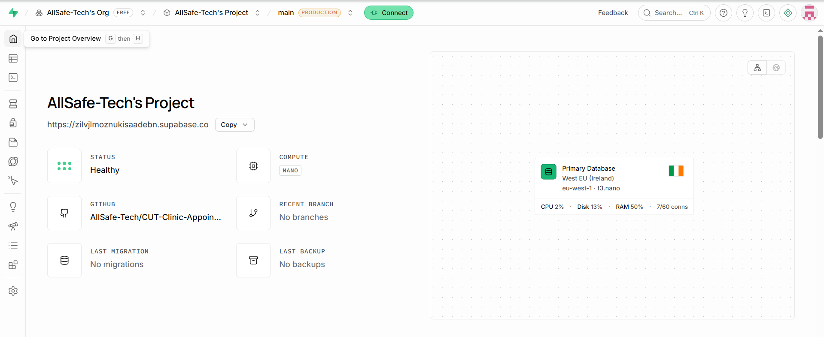

28. Project Progress Tracker and Group Reflection
The ITC327W Project Progress Tracker should be kept current and should show actual task progress, individual contribution, stakeholder engagement, challenges, actions taken, phase summary and group reflection.
https://d.docs.live.net/9fb3b6f4ba9ed92c/Desktop/AllSafe/All_Safe_Tech_Phase1_Project_Progress_Tracker.xlsx

28.1 Group Reflection
The group learned that understanding the stakeholder's current process is important before designing the proposed solution. The current CUT Clinic process relies on Outlook/email and telephone communication and has a two-person email dependency.
One of the main challenges was identifying requirements that could realistically be implemented within the academic timeframe while still addressing the stakeholder's main problem.
Important changes included:
- Removed online payments.
- Removed medical record management.
- Postponed direct CUT-system integration.
- Retained SMS and email notification functionality with prototype limitations.
- Retained the day-before reminder.
- Clarified that authorised clinic staff manage cancellation and rescheduling.
The feasibility study showed that the selected technologies are suitable for the academic prototype, but external notification services, institutional integration, privacy and the academic schedule must be carefully managed.
The three most important risks are:
- Limited project timeframe.
- Dependence on SMS/email services.
- Security and privacy of student information.
The group will improve by:
- Holding regular meetings.
- Updating Microsoft Project.
- Committing work regularly to GitHub.
- Testing components continuously.
- Communicating changes with the stakeholder.
- Prioritising core MVP functionality.

29. Prototype Limitations and Future Considerations
- Production SMS/email delivery depends on external services.
- Test data will be used during development.
- Direct integration with CUT student-information systems is excluded unless authorised access becomes available.
- Production deployment is outside the initial academic scope.
- Formal healthcare compliance is outside the academic prototype.
- Appointment types/services still require final stakeholder confirmation if the clinic requires them.
- Exact advance-booking rules require stakeholder confirmation if required.
- Exact cancellation rules require stakeholder confirmation if required.
- Future versions may include calendar integration, push notifications, analytics and automated CUT-system validation.

30. Definitions and Abbreviations
Term | Meaning
SRS | Software Requirements Specification
CUT | Central University of Technology
Flutter | Framework used to develop the mobile application
Dart | Programming language used with Flutter
ASP.NET Core | Framework used to develop the web application
C# | Programming language used for ASP.NET Core
Supabase | Cloud backend platform
PostgreSQL | Relational database used by Supabase
UML | Unified Modeling Language
ERD | Entity Relationship Diagram
SMS | Short Message Service
MVP | Minimum Viable Product
API | Application Programming Interface
Staff | Authorised CUT Clinic personnel using the web application

Item | Complete
Activity 2.1 Feasibility Study | [ ]
Activity 2.2 Risk Register | [ ]
Feasibility findings reviewed | [ ]
High risks identified | [ ]
Project scope refined | [ ]
Requirements change log completed | [ ]
SRS updated | [ ]
Microsoft Project updated | [ ]
GitHub updated | [ ]
Supabase evidence captured | [ ]
Project Progress Tracker updated | [ ]
Stakeholder changes confirmed | [ ]
Group reflection completed | [ ]
Supporting evidence attached | [ ]

31. Final SRS Status
Item | Current Status
Project | CUT Clinic Appointment Management System
Group | All Safe Tech
Stakeholder | CUT Clinic
SRS Version | 2.0 – Refined Unit 2.3
Current Human Users | CUT Students and Authorised CUT Clinic Staff
Core Problem | Dependence on Outlook/email and telephone communication, with only two staff members receiving relevant emails, which can cause delays when they are unavailable.
Proposed Solution | Flutter Mobile App → Supabase Backend → ASP.NET Core Clinic Web App, with SMS/email notifications and a day-before reminder.
Project Direction | Stakeholder Problem → Requirements → Feasibility → Risks → Refined Scope → System Design → Development → Testing → Demonstration

32. System Architecture and Design

32.1 System Architecture Design
The proposed system consists of a Flutter mobile application for CUT students, an ASP.NET Core web application for authorised clinic staff, and a shared Supabase backend. Supabase provides authentication and PostgreSQL database services. SMS and email are external notification services. Supabase Storage is only required if registration proof documents are retained by the prototype; otherwise it should not be treated as a required component.
- CUT Student → Flutter Mobile Application: registration, login, appointment request, appointment status/details, cancellation and notifications.
- Authorised Clinic Staff → ASP.NET Core Web Application: login, view requests, approve/reject, assign date/time, process cancellation, reschedule and manage appointments.
- Flutter and ASP.NET Core → Shared Supabase backend: authentication and centralised appointment/student/staff/notification data.
- Supabase → SMS/Email services: notification requests for approval, rejection, cancellation, rescheduling and day-before reminders where supported.
- Appointment date/time is assigned by clinic staff; students do not choose the final appointment date/time and do not self-reschedule.
- Only one active/conflicting appointment is permitted for a student at a time.
32.1.1 Architecture Diagram – FINAL DIAGRAM BELOW
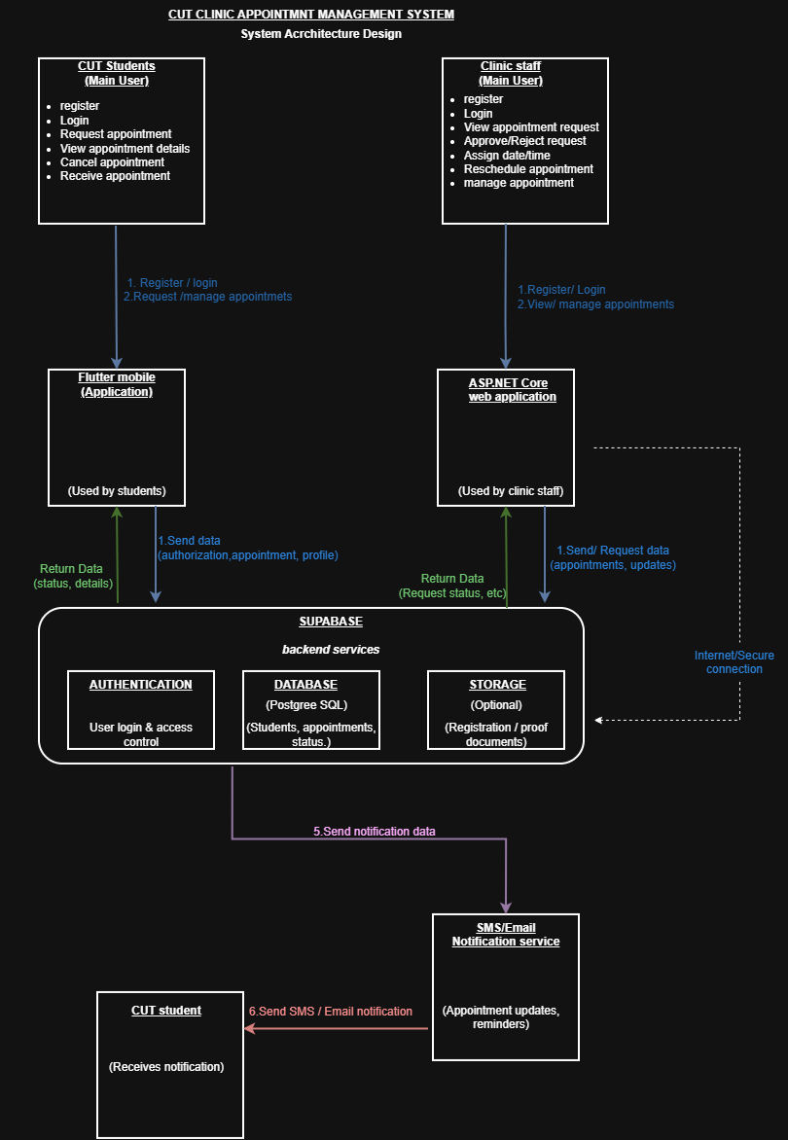
Architecture editable source link |   https://app.diagrams.net/#G1jSp28mVgf8cNvb_ey3je-PorJy07x4Ef#%7B%22pageId%22%3A%22hUQAxqhdT4ggPKcDsRT4%22%7D
32.1.2 Architecture Explanation
The architecture separates the student mobile interface from the clinic staff web interface while using one shared backend. A student request is submitted through Flutter and stored in Supabase. Clinic staff retrieve the request through the ASP.NET Core application and update its status and assigned appointment date/time. The student application then reflects the updated information from the shared backend. Notification processing communicates appointment changes to the student through SMS and/or email where the selected service is available. This design keeps the three core application parts connected as one system.

32.2 UML Design

32.2.1 Use Case Diagram
Required actors for the approved scope include CUT Student and Authorised Clinic Staff. External notification services may be represented where appropriate. The system boundary must clearly identify the proposed CUT Clinic Appointment Management System. Use case names should use clear verb-and-object wording, and any <<include>> or <<extend>> relationships should only be used where justified by the actual process.
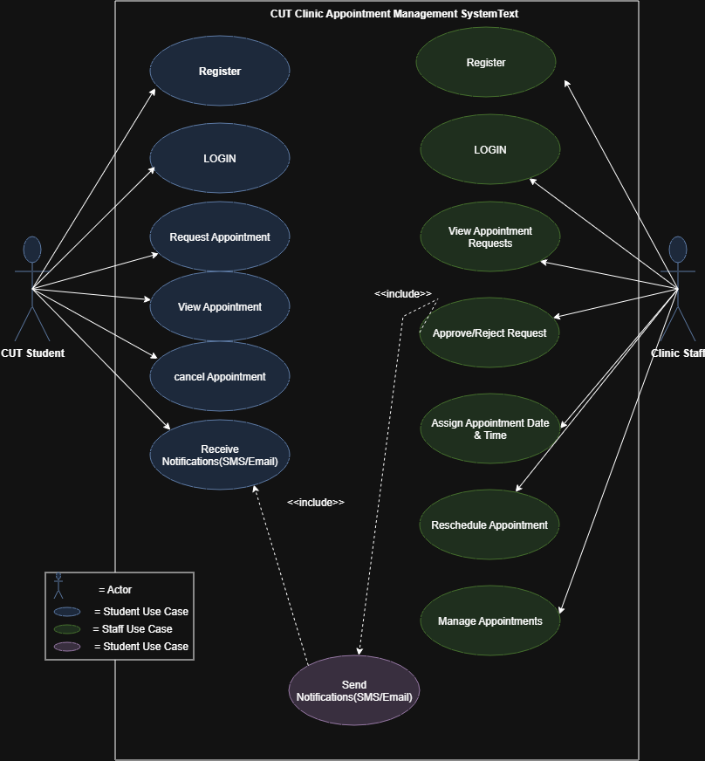
Use Case Diagram editable source link | 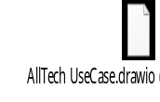  https://app.diagrams.net/#G1Oz4e9vmB6QRyAcWoMEdw4YPrbybLeBc3#%7B%22pageId%22%3A%22i0afifH3hLLM0ks9mapP%22%7D

32.2.2 Sequence Diagram 1 – Flutter + Supabase
Use an important student process, such as requesting an appointment. The diagram must show actors/participants, lifelines, messages, responses and correct interaction order. It must link to an approved use case and requirement.
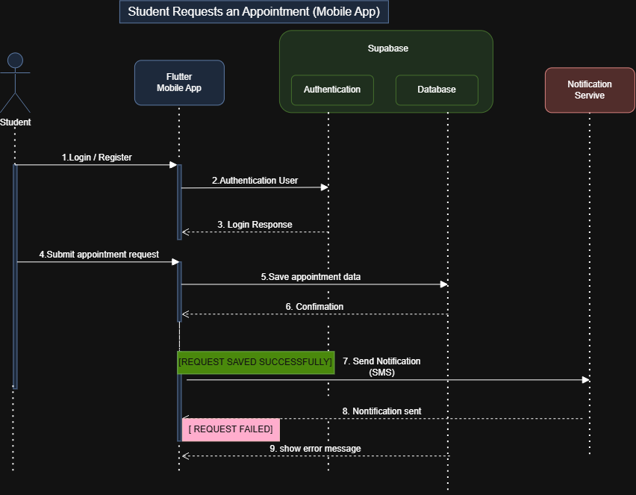
Sequence Diagram 1 editable source link | https://app.diagrams.net/#G13u17z7Rhxo4l-DZeiyzKvT-C7IZSdiYT#%7B%22pageId%22%3A%22BhwzqjSo7ZkxZnFI9Kom%22%7D

32.2.3 Sequence Diagram 2 – ASP.NET Core + Supabase
Use an important clinic-staff process, such as viewing and managing an appointment request. The diagram must show staff, ASP.NET Core, Supabase and the order of requests/responses. It must link to an approved use case and requirement.
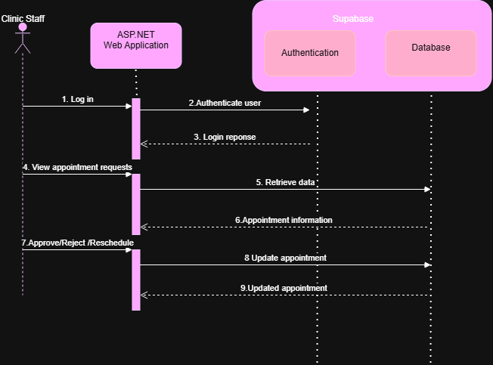
Sequence Diagram 2 editable source link | https://app.diagrams.net/#G1EbNgfHr9ZvscWNQa4dPk5JlQLqEeHS-V#%7B%22pageId%22%3A%22Z6mpGmnxbd0IzQygMM6q%22%7D

32.2.4 UML Requirements Alignment
UML element | Approved requirement/use case supported
Use Case Diagram | Student registration/login, request appointment, view appointment, cancellation; staff login, request management, scheduling/rescheduling, notifications
Sequence Diagram 1 | Student appointment request / mobile-backend interaction
Sequence Diagram 2 | Clinic staff appointment management / web-backend interaction

32.3 Database Design – Entity Relationship Diagram (ERD)
The ERD must represent the information required by the approved system and support both the Flutter and ASP.NET interfaces. The design should show entities/tables, important attributes, primary keys, foreign keys, relationships and cardinality. Fields that are not required by the approved system should not be added without justification.
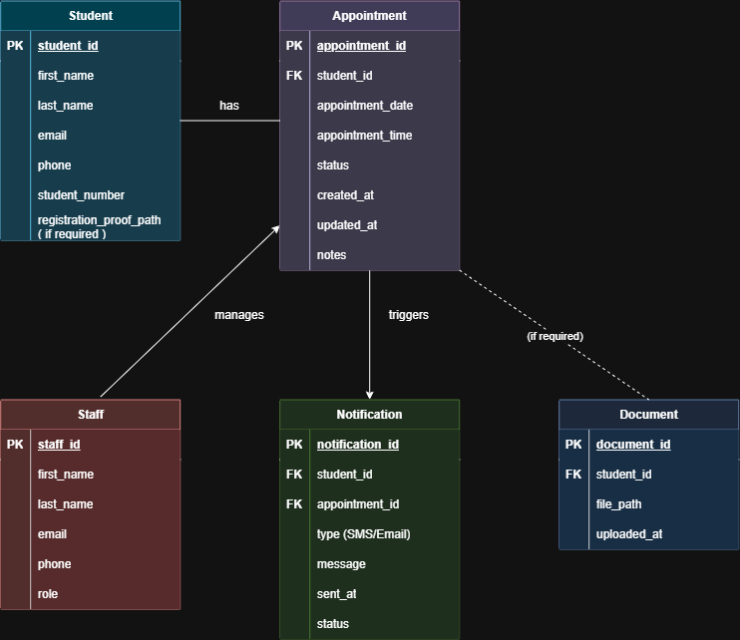
ERD editable source link | https://app.diagrams.net/#G1MiARyUNANOPQ9ldS58XtPxmz3jAIc3o_#%7B%22pageId%22%3A%22Ug-5Qd-pLYUMXqiXg_v-%22%7D
32.3.1 ERD Design Notes
- Student stores the approved student identity/contact information required by the prototype.
- Appointment stores the student relationship, assigned date/time, status and relevant timestamps/notes.
- Appointment_Status represents the controlled appointment states used by the system.
- Staff stores authorised clinic staff information used by the web application.
- Notification stores notification records linked to the relevant student and appointment where implemented.
- Document is optional and should only be included if registration proof is actually retained in the prototype.
- Historical appointments may remain in the database, while the active/conflicting appointment rule prevents a student from creating another active conflicting appointment.
Relationship | Expected cardinality | Requirement supported
Student → Appointment | 1 : 1 | A student can have appointment history .and will have 1 active submission per attempt
Staff → Appointment | 1 : many | Authorised staff assign/manages all appointments.
Appointment_Status → Appointment | 1 : many | Appointment status is controlled and stored.
Appointment → Notification | 1 : many | Appointment events can generate notification records.
Student → Notification | 1 : many | Student receives/has notification records.
Student → Document (if used) | 1 : many | Registration proof can be retained only if required/implemented.

32.4 User Interface Design and Design Alignment
The interfaces must show layout, navigation, data capture, information display and the actions users must perform. Each important interface should be traceable to an approved requirement/use case and to information represented in the ERD.

32.4.1 Flutter Mobile Interface Design
Main student screens to be represented in the final design set include registration, login, home/dashboard, request appointment, review/confirmation, appointment details, cancellation confirmation, notifications and profile/history where included in the approved design. The student does not select the final appointment date/time.
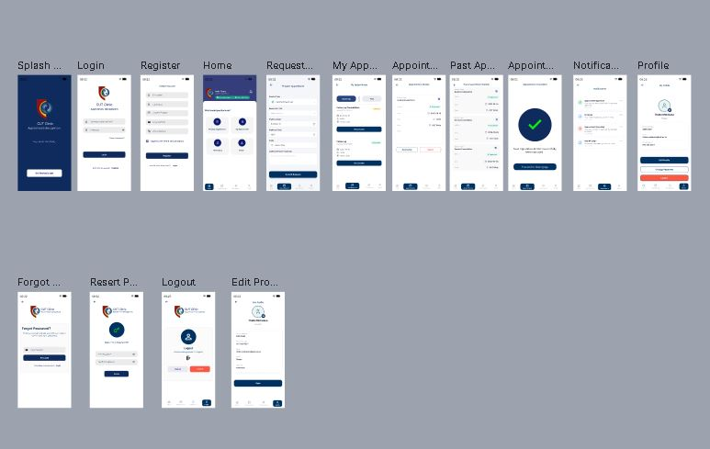
Flutter interface editable source link |  | https://www.figma.com/design/QqKoN65qRhrN6WVPHu879O/Untitled?node-id=0-1&t=qHVgwPH5EOeTbeGR-1
Flutter screen | Purpose / approved function |  | ERD information used
Student Registration | Create CUT student account |  | Student; optional Document if proof is used
Student Login | Authenticate student |  | Authentication / Student
Student Home | Navigate to appointment functions |  | Student / Appointment status
Request Appointment | Capture and submit request |  | Appointment + required request fields
Review / Confirmation | Review and confirm request |  | Appointment
My Appointment | View status, assigned date/time and actions |  | Appointment + Appointment_Status
Cancel Confirmation | Confirm cancellation request |  | Appointment
Notifications | View appointment-related notifications |  | Notification + Appointment
Profile / History | View student details and previous appointments if included |  | Student + Appointment

32.4.2 ASP.NET Core Web Interface Design
Main clinic staff pages should represent the approved staff functions: login, dashboard, appointment requests, appointment details, approve/reject, assign date/time, reschedule and manage appointments. Access is restricted to authorised clinic staff.
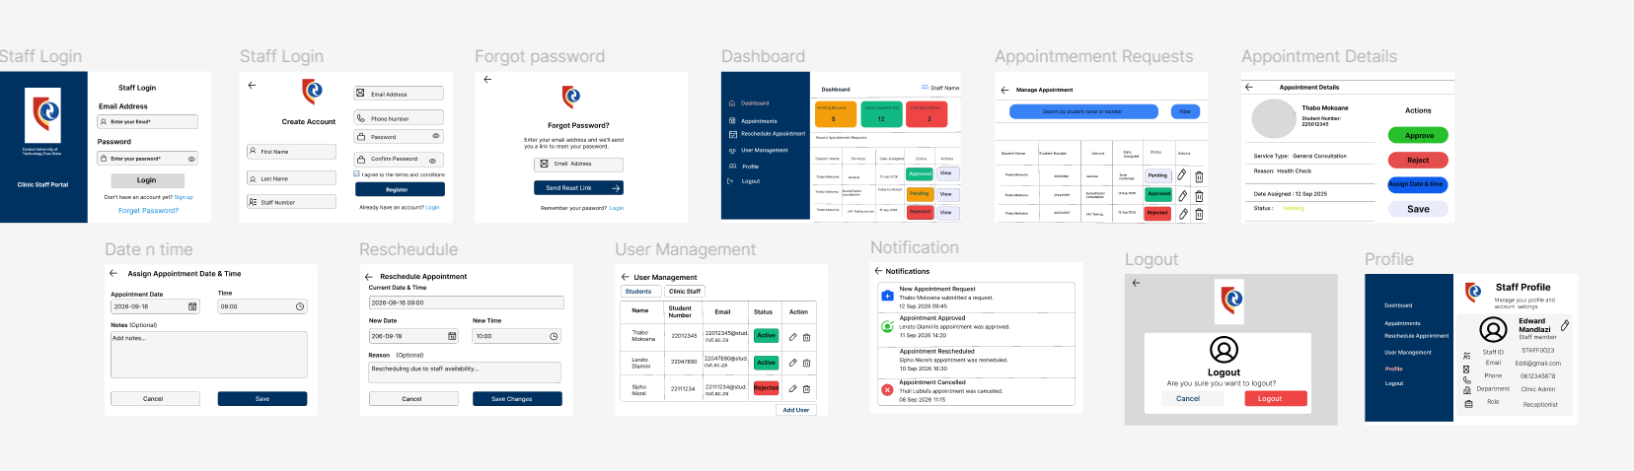

ASP.NET interface editable source link |  | https://www.figma.com/design/Z9Rqr7GW2tLwfI4TLNRooO/Untitled?node-id=0-1&t=flvtvE1uMji3L2jY-1
ASP.NET page | Purpose / approved function |  | ERD information used
Staff Login | Authenticate authorised clinic staff |  | Staff / Authentication
Dashboard | Overview/navigation |  | Appointment / Status
Appointment Requests | View pending requests |  | Appointment + Student + Status
Appointment Details | View full request and appointment information |  | Student + Appointment + Status
Approve / Reject | Update appointment request status |  | Appointment + Appointment_Status
Assign Date & Time | Staff assigns appointment date/time |  | Appointment
Reschedule | Staff changes appointment date/time |  | Appointment
Manage Appointments | View/manage existing appointments |  | Appointment + Student + Status

32.4.3 Navigation Design
Insert the final navigation-flow design below. It may be a separate navigation diagram or a labelled part of the interface design board.
Navigation / interface source link (if separate) | Link for ASP.NET: https://www.figma.com/proto/Z9Rqr7GW2tLwfI4TLNRooO/Untitled?node-id=1-2&p=f&t=JhqdUdrZ1x0DqOrr-1&scaling=contain&content-scaling=fixed&page-id=0%3A1  Link for Flutter:https://www.figma.com/proto/Z9Rqr7GW2tLwfI4TLNRooO/Untitled?node-id=1-2&p=  f&t=ipF4LhGap7Wz4Fmo-1&scaling=contain&content-scaling=fixed&page-id=0%3A1

32.5 Design Alignment

Requirement / approved function | Use Case | Sequence | ERD element(s) | Interface
Student registration with valid CUT student information | Register | Sequence 1 if included | Student; Document if required | Flutter Registration
Student submits appointment request | Request Appointment | Sequence 1 | Appointment + Student | Flutter Request Appointment
Staff views/manages appointment requests | View / Manage Appointment Requests | Sequence 2 | Appointment + Student + Status | ASP.NET Appointment Requests
Staff approves/rejects and assigns date/time | Approve/Reject; Assign Date & Time | Sequence 2 | Appointment + Appointment_Status | ASP.NET Appointment Details / Assign Date & Time
Student views appointment status/date/time | View Appointment Details | Sequence 1 or relevant student sequence | Appointment + Appointment_Status | Flutter My Appointment
Student cancellation | Cancel Appointment | Relevant sequence if included | Appointment + Appointment_Status | Flutter Cancel Confirmation
Staff rescheduling | Reschedule Appointment | Sequence 2 | Appointment | ASP.NET Reschedule
SMS/email notification and reminder | Receive/Send Notifications | Relevant notification messages | Notification + Appointment | Flutter Notifications / notification service

32.6 Original Editable Design Source Links
The assessment requires working links to the original editable design sources. Paste the actual links below and test each link from a normal browser/account before submission. If an offline tool was used, replace the link with the editable file name and include that file in the submission ZIP.
Design artefact | Tool used | Working editable link OR editable file name
System Architecture Diagram | Draw.io
Use Case Diagram | Draw.io | 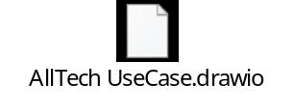
Sequence Diagram 1 – Flutter + Supabase | Draw.io | 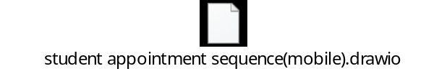
Sequence Diagram 2 – ASP.NET + Supabase | Draw.io | 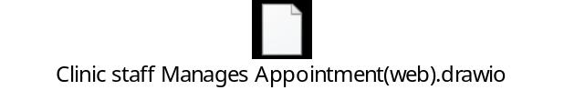
ERD | Draw.io | 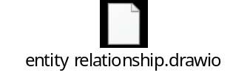
Flutter Interface Designs | Figma | https://www.figma.com/design/QqKoN65qRhrN6WVPHu879O/Untitled?node-id=0-1&t=qHVgwPH5EOeTbeGR-1
ASP.NET Interface Designs | Figma | https://www.figma.com/design/Z9Rqr7GW2tLwfI4TLNRooO/Untitled?node-id=0-1&t=0pp4JiMH5MzSsARw-1

32.7 Microsoft Project, GitHub and Project Progress Evidence

32.7.1 Microsoft Project Schedule Screenshot
The schedule should show the actual Phase 2 state and include design activities, dates, durations, dependencies, responsibilities, milestones, review/feedback, Flutter development, ASP.NET development, Supabase development/integration, testing/corrections and final presentation preparation as applicable.
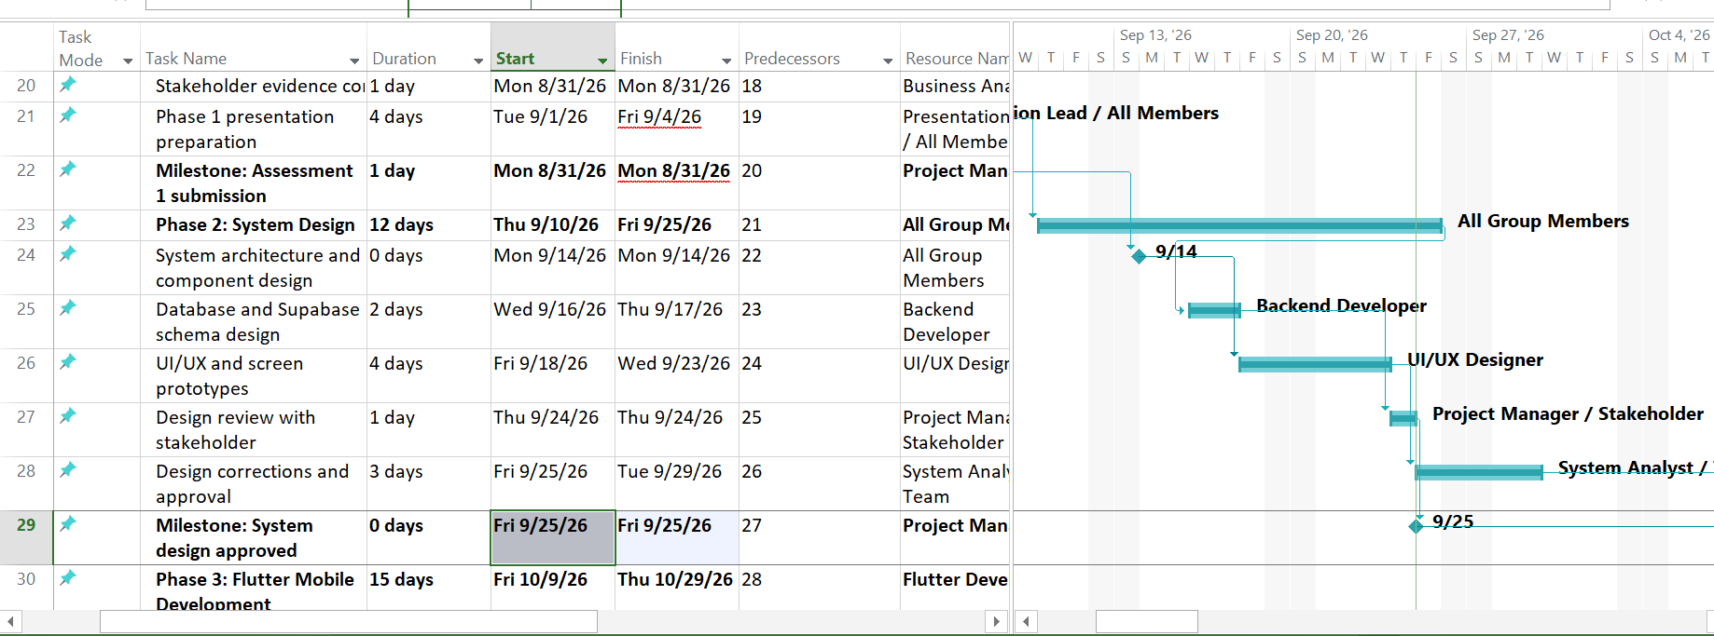
Original editable Microsoft Project file name / location in submission ZIP | 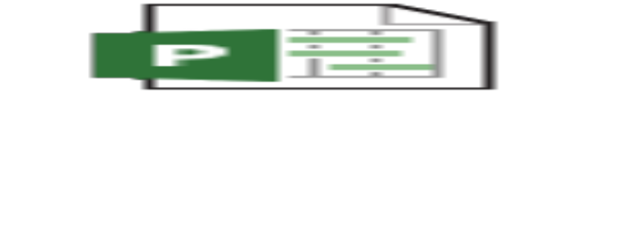

32.7.2 GitHub Repository
Current project repository identified in the SRS:
https://github.com/AllSafe-Tech/CUT-Clinic-Appointment-Management-System.git
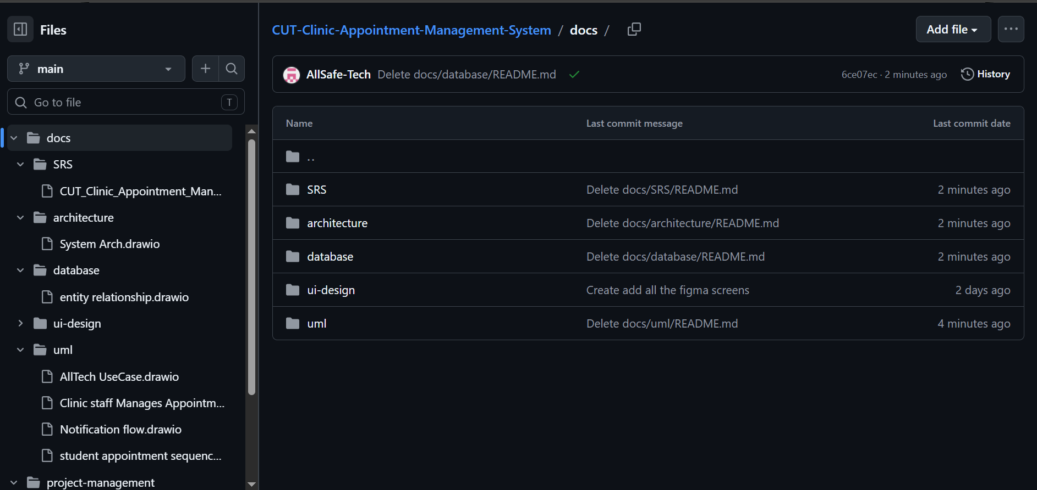

https://github.com/AllSafe-Tech/CUT-Clinic-Appointment-Management-System.git repository link (verify before submission) | https://github.com/AllSafe-Tech/CUT-Clinic-Appointment-Management-System.git

33. Phase 3 – Development, Integration and Testing Update
Document update note: This Phase 3 addendum supplements the preceding SRS. Sections 1–32, the existing requirements, feasibility analysis, risks, stakeholder notes, design descriptions and original evidence have been retained. This addendum does not replace earlier phase records.

33.1 Implementation Overview
The project has progressed from requirements and system design into implementation of the integrated academic prototype. The solution uses a Flutter/Dart student mobile application, an ASP.NET Core/C# staff web application and a shared Supabase/PostgreSQL backend. The two interfaces use the shared backend so that appointment information updated by clinic staff can be reflected in the student application.

33.2 Implemented or Reported Working Functionality
- Staff authentication and access to the ASP.NET Core clinic web application.
- Student appointment requests submitted through the Flutter application are available to clinic staff through the shared Supabase backend.
- Clinic staff can review requests and approve or reject them, and assign an appointment date and time.
- Staff can reschedule an approved appointment when required; students do not assign their own final appointment date/time or self-reschedule.
- Student cancellation and the one-active-appointment rule are part of the current implementation.
- Appointment scheduling includes checks intended to prevent past date/time selections and conflicting bookings.
- Student details and appointment history, including completed appointments, are displayed in the staff interface.
- Dashboard statistics and email notification sending have been reported as working during development.

33.3 Notification Status and Limitations
Email notification sending has been reported as working in development. SMS delivery has not been verified end-to-end because the project is not using a purchased Twilio number; therefore, SMS must not be described as fully tested or production-ready. Day-before reminders and any notification paths not backed by current test evidence must remain marked as requiring verification. External service availability, account configuration and delivery remain limitations of the academic prototype.

33.4 Documents and Registration Proof
The project has a documents data structure intended to associate uploaded documents with students. Any staff-side review or approval/rejection workflow must be marked complete only after it has been tested against the current database schema and a test student record. Do not imply that all document-review scenarios have passed unless test evidence is recorded.

33.5 Current Database and Design Alignment
The implemented database continues to use the existing Supabase schema and relationships. The current project data model includes student, appointment, staff, notification and document records, alongside appointment status and service-related data used by the implementation. The SRS diagrams and explanations should be checked against the actual deployed schema before final submission; do not introduce an administrator role or unimplemented foreign-key relationships into the documentation.

33.6 Verification and Evidence Register
Area | Current statement | Evidence/action still required
Flutter–Supabase–ASP.NET integration | Integrated appointment flow reported working | Capture dated screenshots or demonstration evidence; attach relevant non-secret GitHub commit links.
Appointment approval/rejection and scheduling | Reported implemented | Test pending, approved, rejected, cancelled and rescheduled cases.
Past date/time and double-booking checks | Reported implemented | Record test cases for past dates, past times and conflicting appointment slots.
Email notifications | Email sending reported working | Retain a successful test email and test status-change scenarios.
SMS notifications | Not verified end-to-end | Leave unverified/blocked until a genuine end-to-end test is available.
Day-before reminder | Not confirmed by evidence in this update | Test reminder timing and delivery before marking complete.
Student details and appointment history | Reported implemented | Verify profile and history, including completed appointments.
Document review workflow | Requires evidence-based confirmation | Test document retrieval, authorised staff action, and saved approval/rejection status.
Security and access control | Must be validated as part of final testing | Verify staff-only web pages, student data access boundaries, and that secrets are not committed.
GitHub contribution evidence | To be recorded from actual repository activity | Add real commit/PR links and do not assign work to a member without evidence.

33.7 Phase 3 Risks and Actions
- External SMS delivery is constrained by the absence of a configured/purchased sender; demonstrate email and document the SMS limitation honestly.
- Integration changes can introduce regressions; run focused tests after changes to appointment models, services, controllers and views.
- The database and SRS diagrams can drift apart; compare documentation with the live Supabase schema before submission.
- GitHub contribution claims must be supported by actual commits, pull requests, documentation or other verifiable work evidence.
- Protect student information and credentials; use test data where possible and never commit passwords, publishable/private keys, service-role keys or confidential student records.

33.8 Phase 3 Summary
Phase 3 has moved the project into implementation and integration. Core appointment flows, staff-side management and email sending have been reported as working. The project should not be described as fully complete until the group has recorded test evidence, verified outstanding document and reminder workflows, reviewed security and access controls, and prepared a demonstration. This update records known progress without changing or deleting the previous phase information.

33.9 Numbered Application Screenshots and Explanations
The following screenshots are numbered by application. Each caption briefly describes the screen shown. All original document content and embedded pictures have been retained.
Flutter Screen 1 – Student Login
This screen allows registered students to sign in to the CUT Clinic mobile application using their login details.
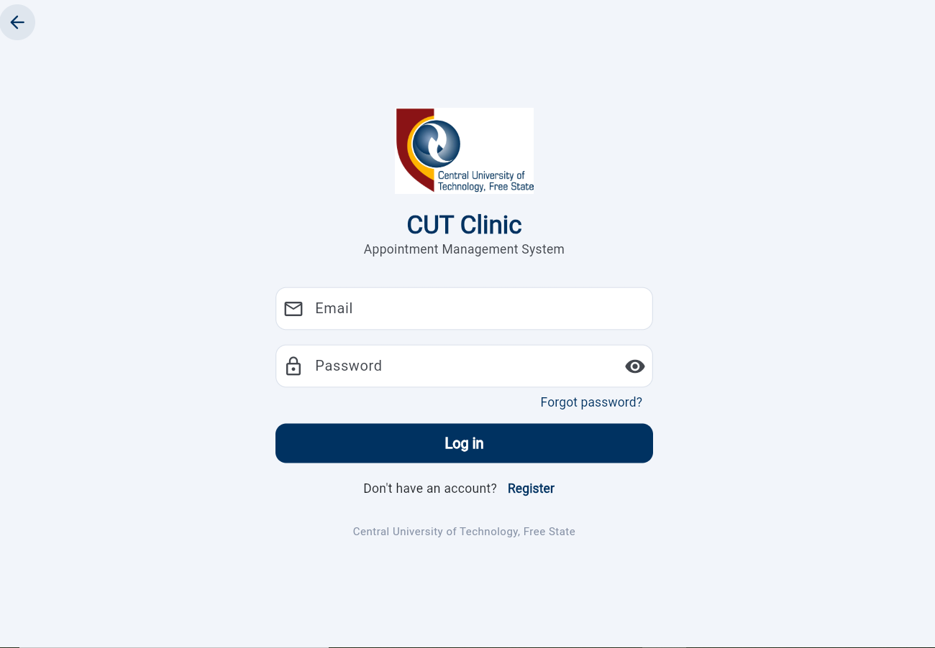

Flutter Screen 2 – Main Screen
This screen displays our main screen
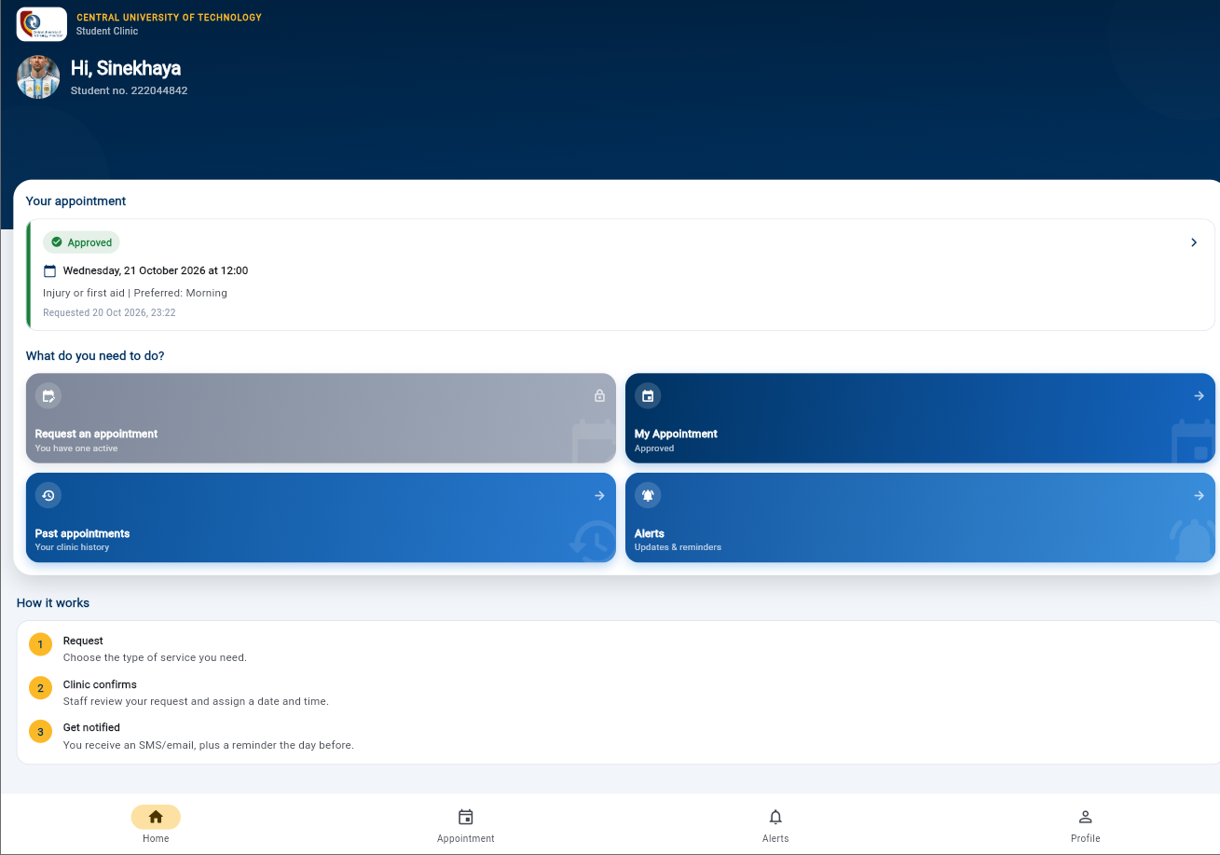
Flutter Screen 2 – My Appointment
This screen displays the student’s appointment information, including its current status and scheduled details when available.
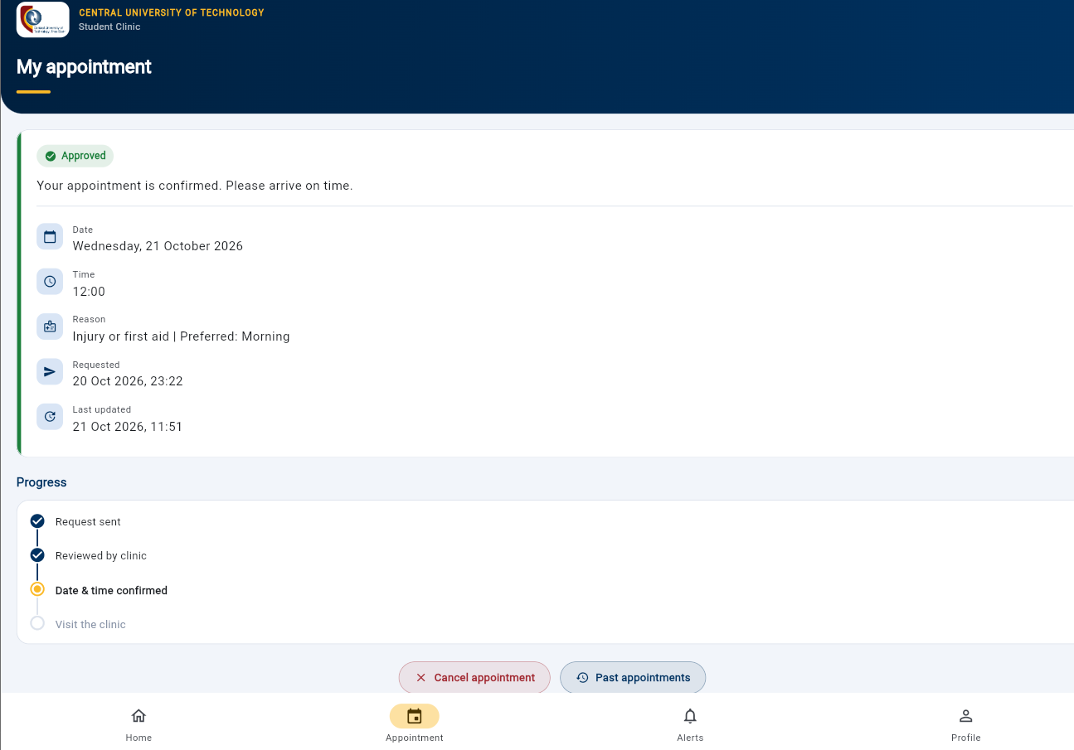

Flutter Screen 3 – Cancel Appointment Confirmation
This confirmation dialog asks the student to confirm or stop the cancellation before the action proceeds.
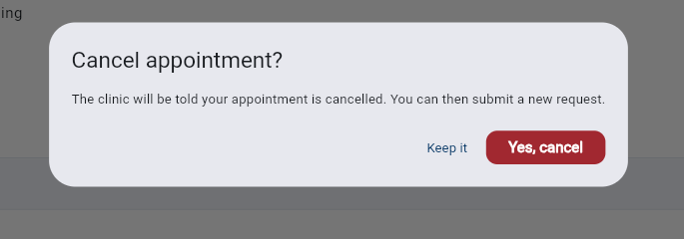
Flutter Screen 4 – Notifications
This screen lists notifications sent to the student about appointment-related updates.
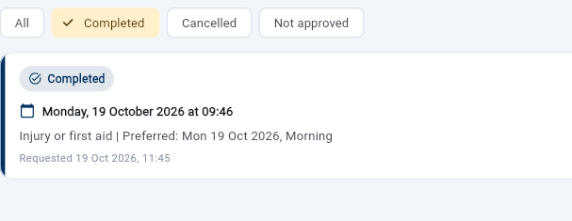

Flutter Screen 5 – Appointment Status / History
This screenshot shows appointment status information that helps the student review the state of an appointment.
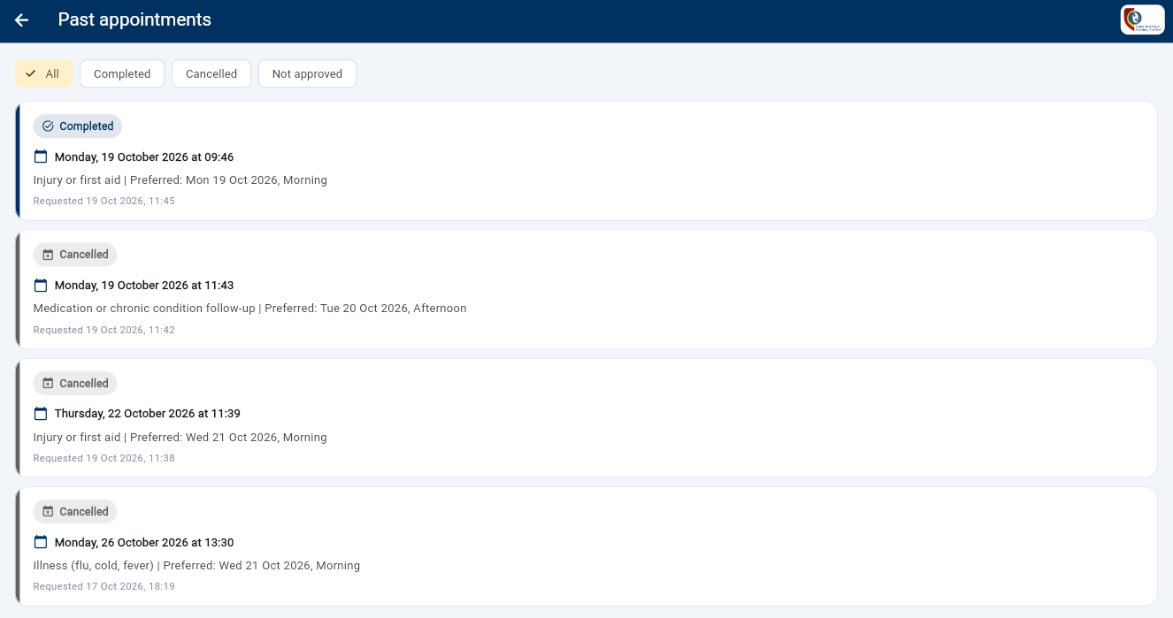
Flutter Screen 6 – Notification Message / Content
This image provides notification-related content used to communicate appointment updates.

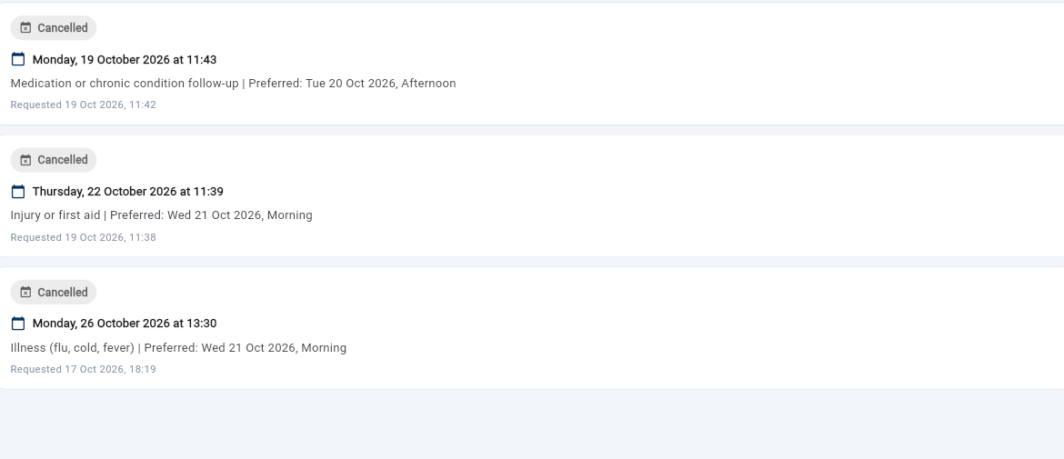
Flutter Screen 7 – Notifications List
This screen provides a view of notifications available to the student. It supports checking updates from the clinic.
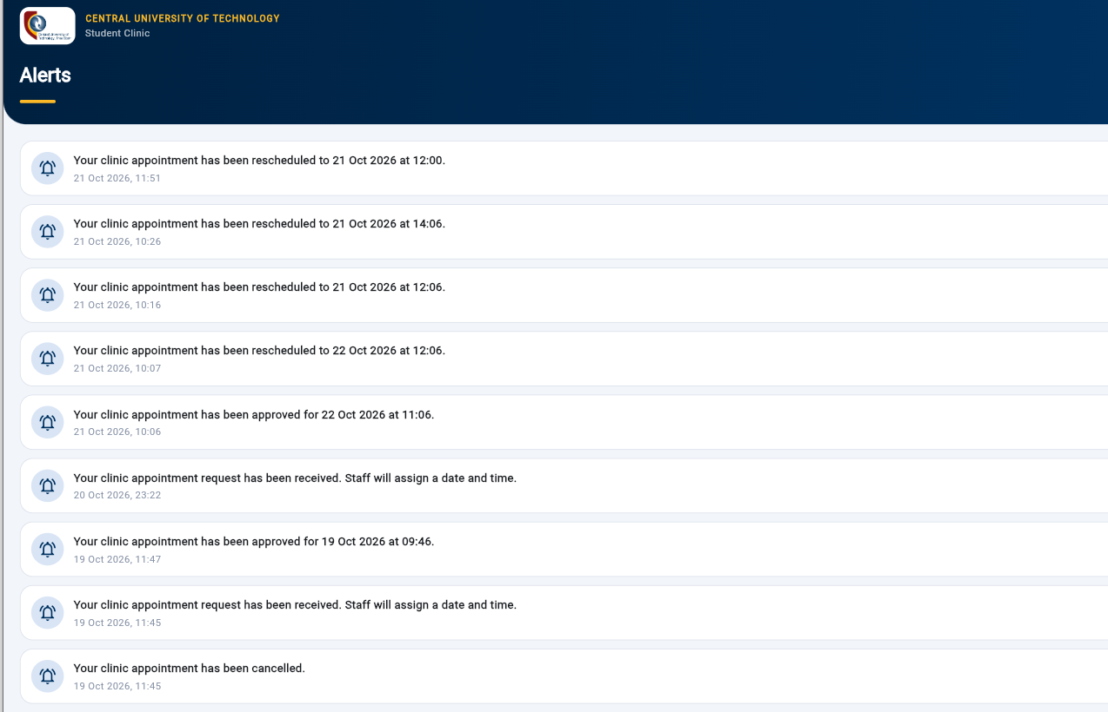
Flutter Screen 8 – My Profile
This screen presents the student’s appointment area and available appointment information or actions.
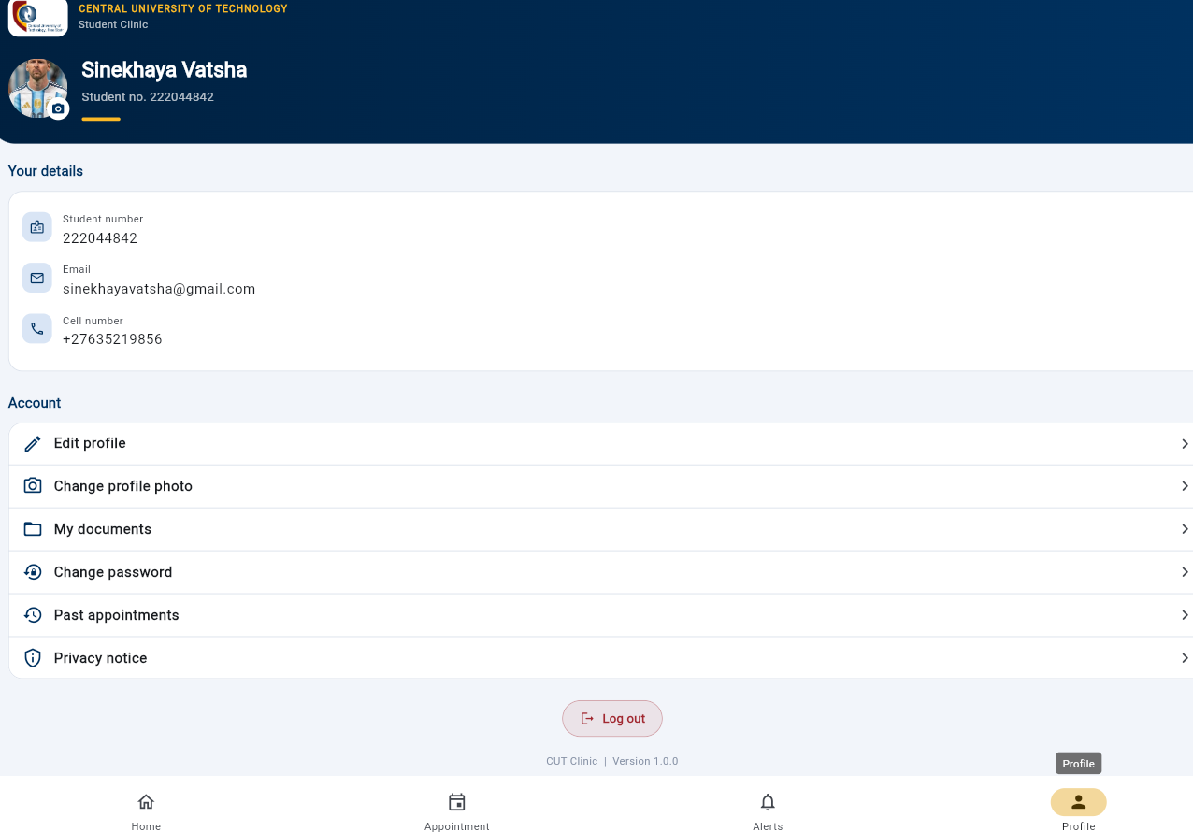
Flutter Screen 9 – Logout Confirmation
This dialog asks the student to confirm whether they want to sign out of the mobile application.
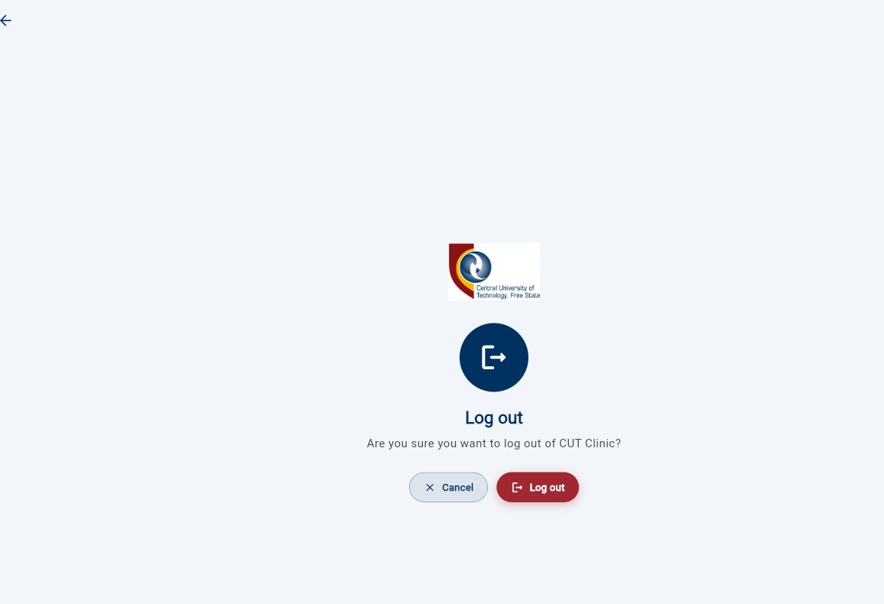
Flutter Screen 10 – Student Registration
This form allows a new student to enter the required information to register for the mobile application.
ASP.NET Screen 1 – Staff Login
This screen allows authorised clinic staff to sign in to the ASP.NET Core web application.
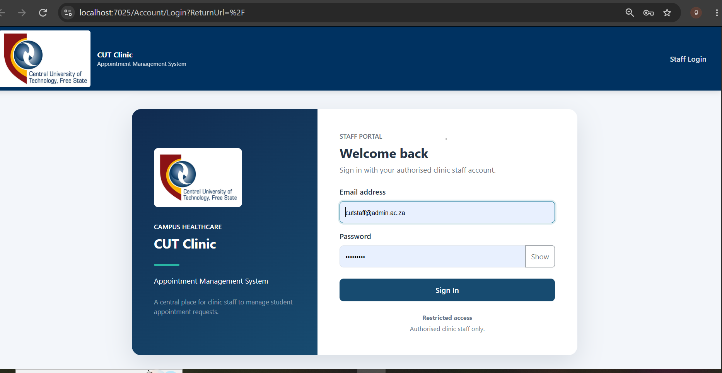
ASP.NET Screen 2 – Staff Dashboard
This staff dashboard presents a summary of clinic activity and provides access to appointment-management information.
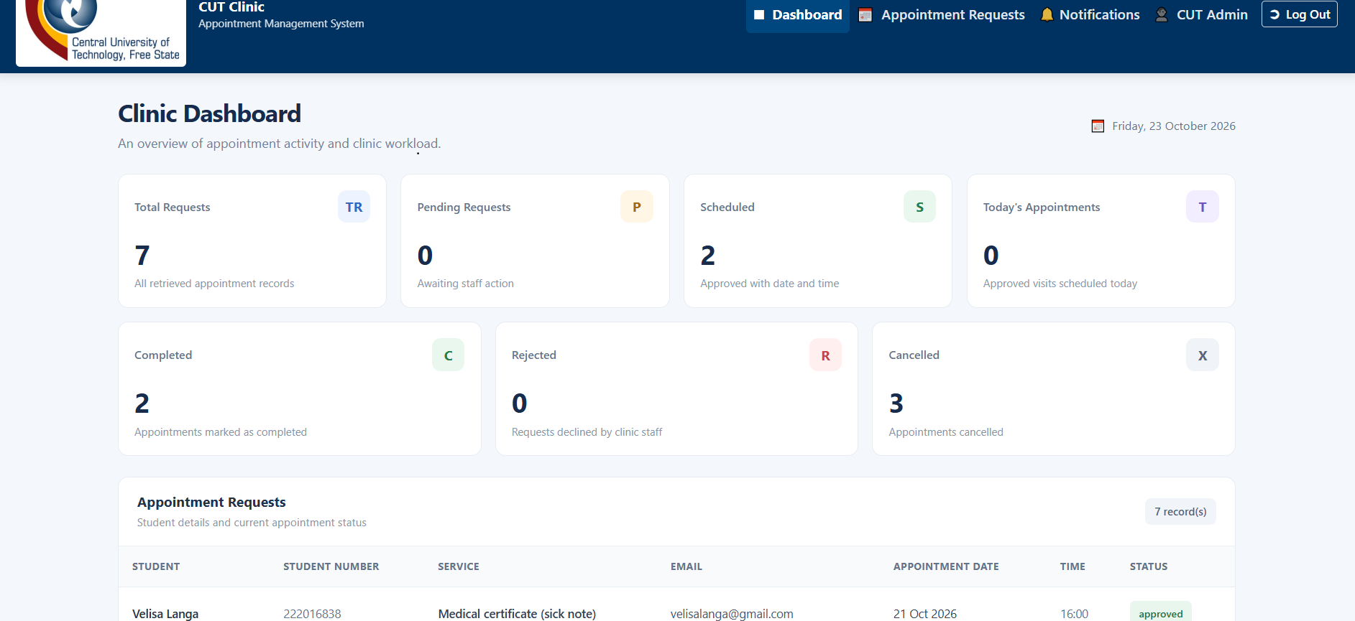

ASP.NET Screen 3 – Student Details
This page displays student information for clinic staff and supports reviewing student-related records.
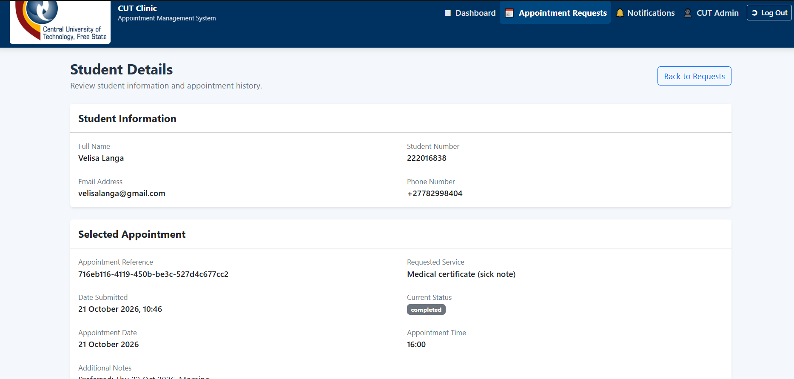
ASP.NET Screen 4 – Student Details / Appointment History
This screenshot displays student details and appointment-history information for staff review.
ASP.NET Screen 5 – Staff Appointments Notifications
This screenshot displays students appointments request notifications for staff review.
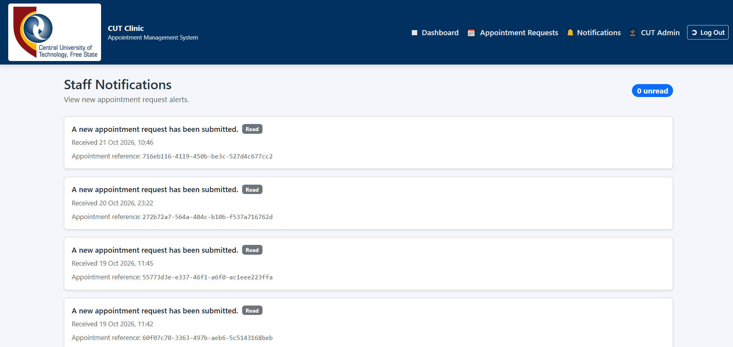
ASP.NET Screen 6 – Staff profile / Logout
This screenshot displays
